**Project Title: Robust Operational space motion control of a waist assistive powered exoskeleton**

Milestone1: MATLAB codes for upper body exoskeleton;

Report consists of data based on Matlab Simulations carried out to analyse the dynamic behaviour of human being while lifting and weight carrying operations. Few assumption have been made while carrying out this analysis they are mentioned as follows:

* Either side of the human body is having equal weight
* Human body is fully symmetric
* Center of mass of the limb is at its geometrical center.
* This analysis is done for a fit human adult having weights 50kg and 75 kg for drawing approximate reference.
* Spring constant=6kg per mm;

The following limb lengths are used for the analysis

* Waist width=0.3 m
* Crus = 0.45m
* Thigh = 0.5m
* Spine = 0.0.85m
* Shoulder = 0.6m
* Bicep arm = 0.4m
* Forearm=0.4m

height of human =1.85 m (6 feet approx)

**Desired test motion and stances**

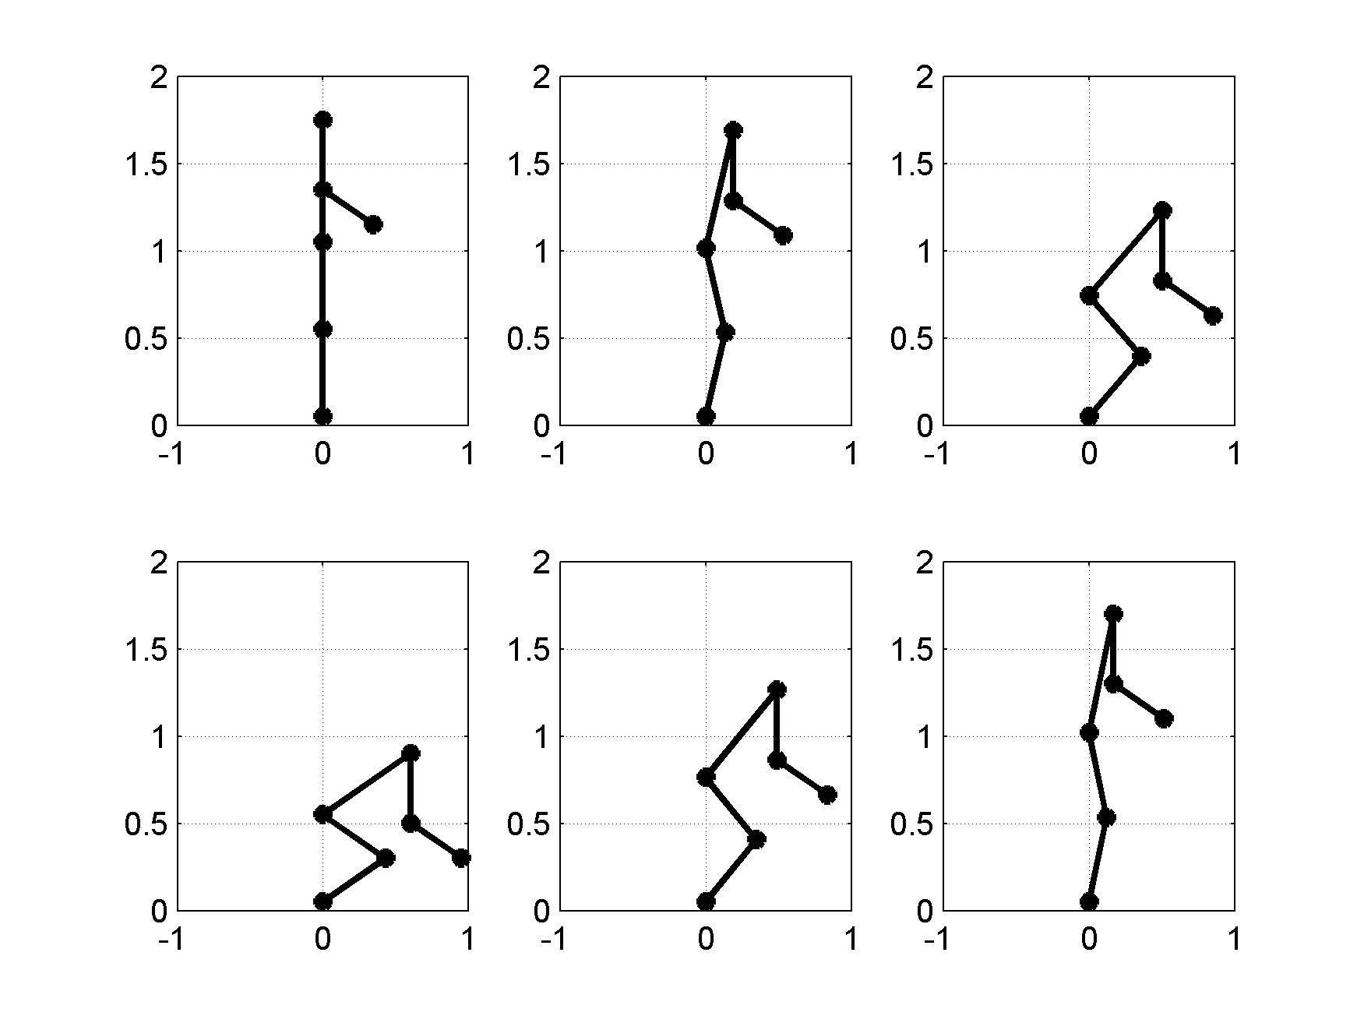

Figure:1: Test motion stances

**For the case of lifting weight from ground 🡪**

**Case 1: Weight of Human = 50 kg, Zero payload 🡪**

1. No load on hands

Action: sitting and getting up

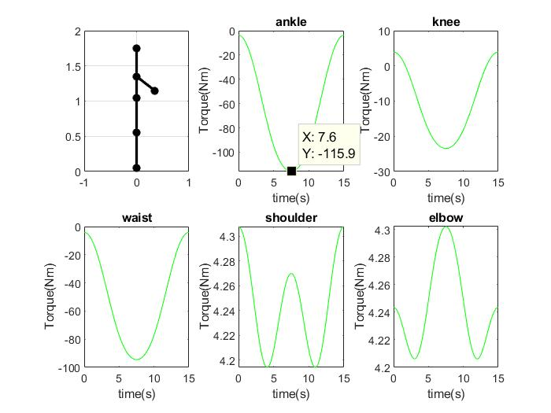

Figure:1: Torque graph for sitting down and getting up without load at operation time =15 s

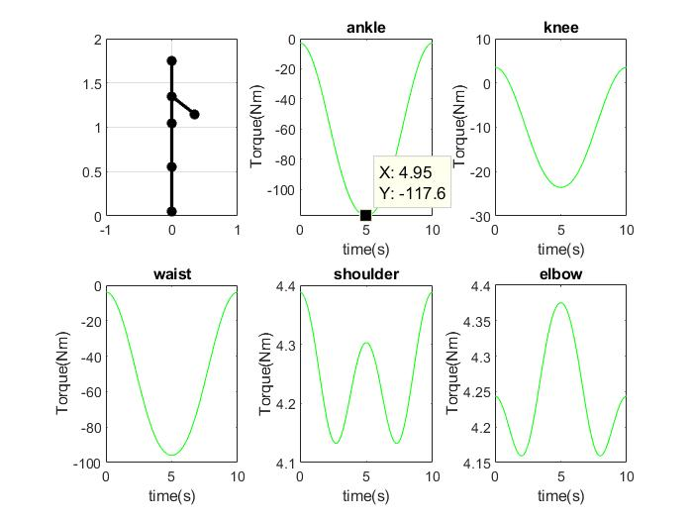

Figure:2: Torque graph for sitting down and getting up without load at operation time =10 s

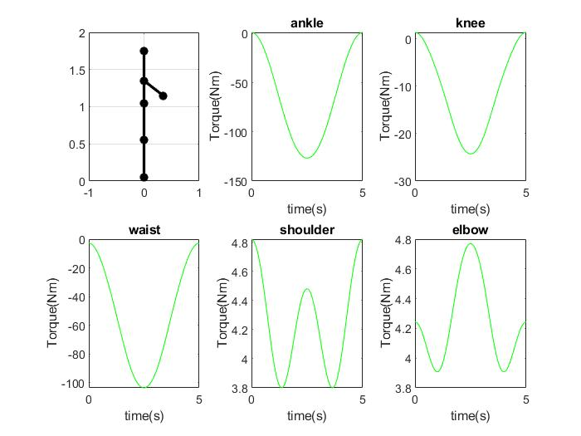

Figure:2: Torque graph for sitting down and getting up without load at operation time =5 s

1. Maximum torque on human joints at different time of operation

|  |  |  |  |  |  |  |
| --- | --- | --- | --- | --- | --- | --- |
| S.no | Operation time (in sec) | Maximum Torque on ankle (in Nm) | Maximum Torque on knee (in Nm) | Maximum Torque on waist (in Nm) | Maximum Torque on shoulder (in Nm) | Maximum Torque on  Elbow (in Nm) |
| 1. | 15 | 115.9 | 23.44 | 94.5 | 4.308 | 4.302 |
| 2. | 13 | 116.4 | 23.48 | 94.88 | 4.329 | 4.321 |
| 3. | 12 | 116.7 | 23.50 | 95.14 | 4.344 | 4.335 |
| 4. | 10 | 117.5 | 23.6 | 95.93 | 4.388 | 4.375 |
| 5. | 9 | 118.3 | 23.63 | 96.51 | 4.422 | 4.406 |
| 6. | 8 | 119.3 | 23.7 | 97.38 | 4.47 | 4.449 |
| 7. | 7 | 120.7 | 23.82 | 98.61 | 4.539 | 4.512 |
| 8. | 6 | 122.9 | 23.99 | 100.5 | 4.645 | 4.609 |
| 9 | 5 | 126.7 | 24.27 | 103.7 | 4.822 | 4.771 |
| 10 | 4 | 133.4 | 24.8 | 109.3 | 5.148 | 5.067 |

**Case 2: Weight of Human = 50 kg, payload = 5kg 🡪**

1. Load on Hands = 5kg

Action: sitting and getting up

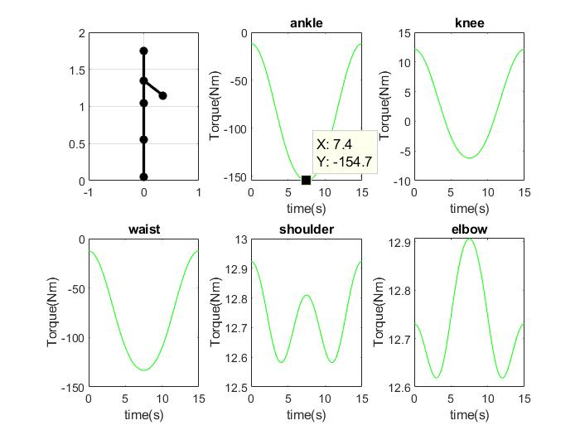

Figure:4: Torque graph for sitting down and getting up with load of 5kg at operation time =15 s

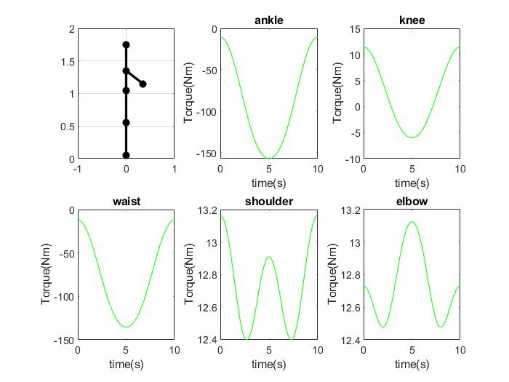

Figure:5: Torque graph for sitting down and getting up with load of 5kg at operation time =10 s

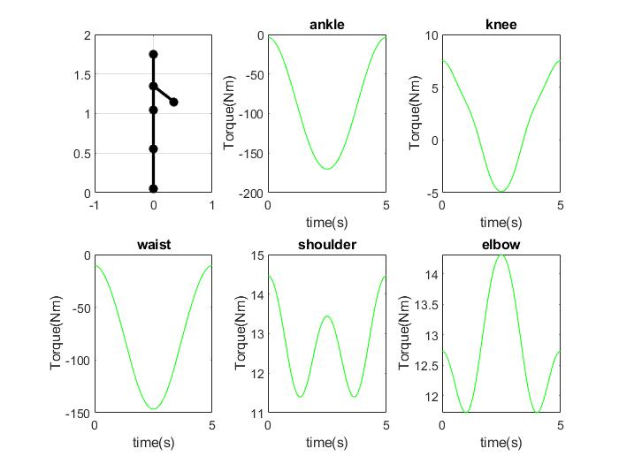

Figure:6: Torque graph for sitting down and getting up with load of 5kg at operation time =5 s

1. Maximum torque on human joints at different time of operation

|  |  |  |  |  |  |  |
| --- | --- | --- | --- | --- | --- | --- |
| S.no | Operation time (in sec) | Maximum Torque on ankle (in Nm) | Maximum Torque on knee (in Nm) | Maximum Torque on waist (in Nm) | Maximum Torque on shoulder (in Nm) | Maximum Torque on  Elbow (in Nm) |
| 1. | 15 | 154.7 | 12.15 | 133.2 | 12.92 | 12.91 |
| 2. | 13 | 155.3 | 11.96 | 133.8 | 12.99 | 12.96 |
| 3. | 12 | 155.7 | 11.83 | 134.1 | 13.03 | 13 |
| 4. | 10 | 157.1 | 11.4 | 135.3 | 13.16 | 13.13 |
| 5. | 9 | 158.2 | 11.12 | 136.1 | 13.27 | 13.22 |
| 6. | 8 | 159.6 | 10.7 | 137.4 | 13.41 | 13.35 |
| 7. | 7 | 161.7 | 11.07 | 139.2 | 13.62 | 13.54 |
| 8. | 6 | 164.9 | 9.113 | 141.9 | 13.94 | 13.83 |
| 9 | 5 | 170.2 | 7.522 | 146.5 | 14.47 | 14.31 |
| 10 | 4 | 180 | 4.591 | 154.9 | 15.44 | 15.2 |

**Case 3: Weight of Human = 50 kg, Payload = 25kg 🡪**

1. Payload on hands=50 kg

Action: sitting and getting up

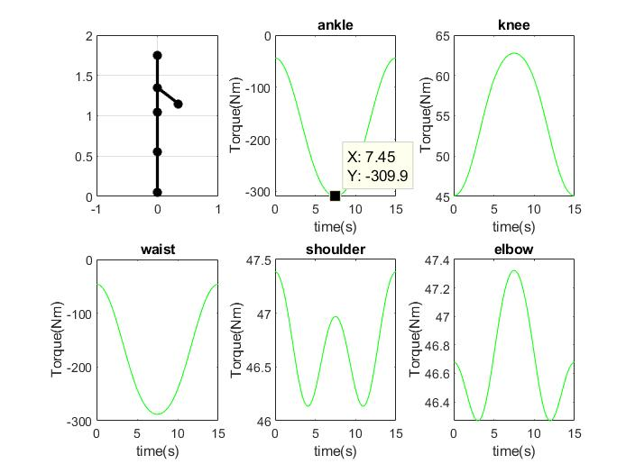

Figure:7: Torque graph for sitting down and getting up without load at operation time =15 s

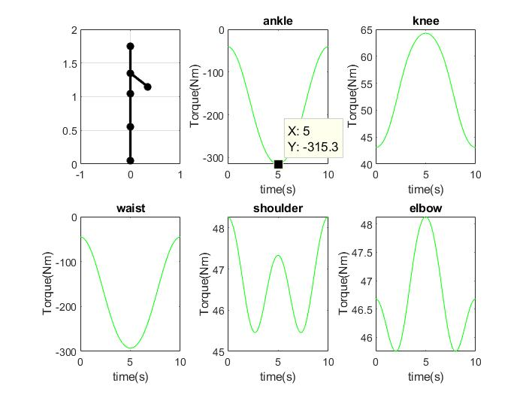

Figure:8: Torque graph for sitting down and getting up without load at operation time =10 s

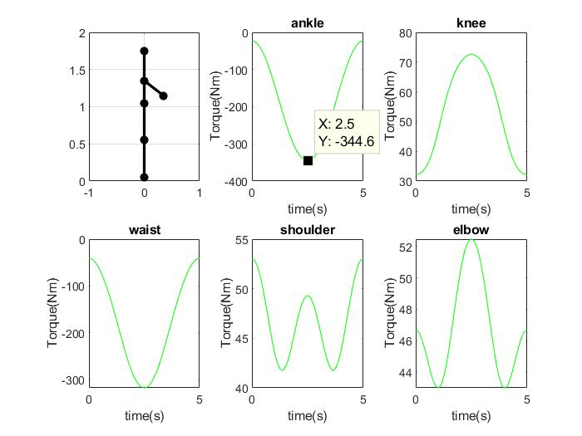

Figure:9: Torque graph for sitting down and getting up without load at operation time =5 s

1. Maximum torque on human joints at different time of operation

|  |  |  |  |  |  |  |
| --- | --- | --- | --- | --- | --- | --- |
| S.no | Operation time (in sec) | Maximum Torque on ankle (in Nm) | Maximum Torque on knee (in Nm) | Maximum Torque on waist (in Nm) | Maximum Torque on shoulder (in Nm) | Maximum Torque on  Elbow (in Nm) |
| 1. | 15 | 309.9 | 62.76 | 288.1 | 47.39 | 47.32 |
| 2. | 13 | 311.3 | 63.16 | 289.3 | 47.72 | 47.52 |
| 3. | 12 | 312.3 | 63.45 | 290.3 | 47.78 | 47.69 |
| 4. | 10 | 315.3 | 64.3 | 292.7 | 48.27 | 48.13 |
| 5. | 9 | 317.6 | 64.94 | 294.7 | 48.64 | 48.47 |
| 6. | 8 | 320.8 | 65.85 | 297.5 | 49.17 | 48.94 |
| 7. | 7 | 325.4 | 67.16 | 301.5 | 49.93 | 49.64 |
| 8. | 6 | 332.6 | 69.21 | 307.5 | 51.1 | 50.71 |
| 9 | 5 | 344.6 | 72.59 | 318 | 53.05 | 52.48 |
| 10 | 4 | 366.5 | 78.81 | 336.9 | 56.63 | 55.74 |

**Case 4: Weight of Human = 85 kg, No Payload 🡪**

1. No load on hands

Action: sitting and getting up

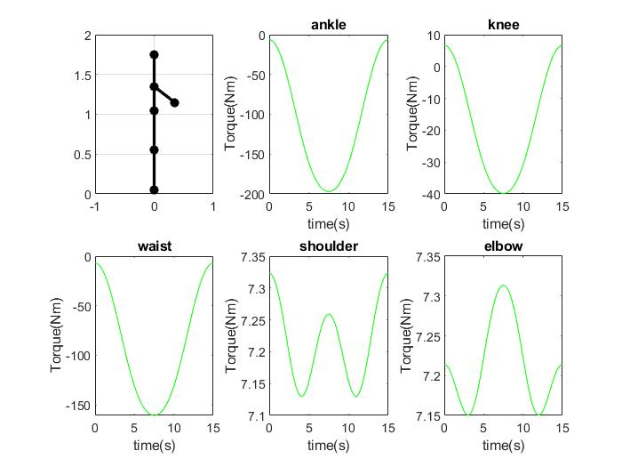

Figure:10: Torque graph for sitting down and getting up without load at operation time =15s

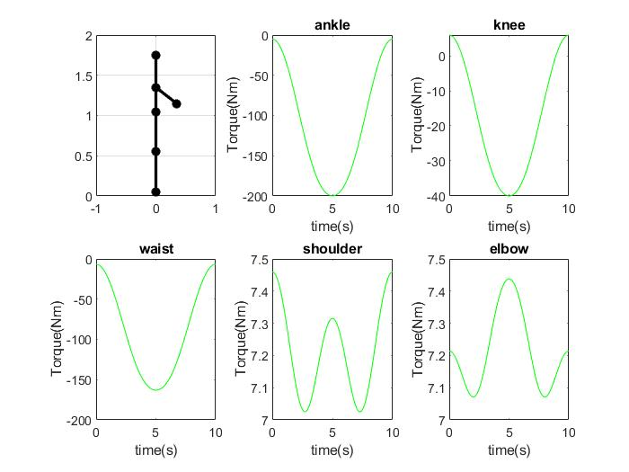

Figure:11: Torque graph for sitting down and getting up without load at operation time =10s

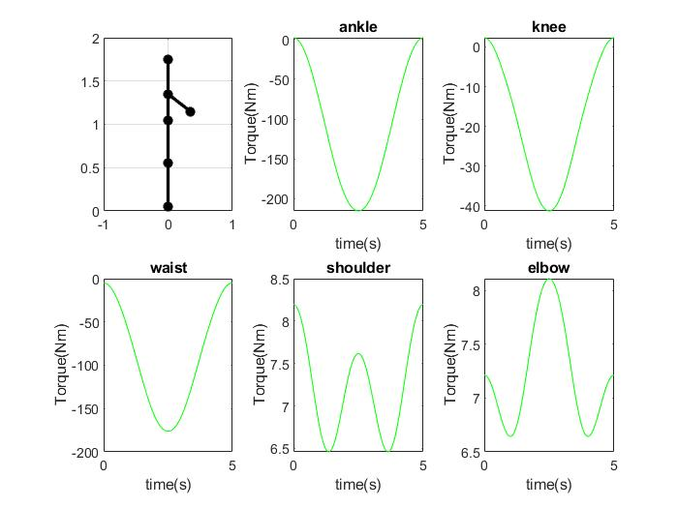

Figure:12: Torque graph for sitting down and getting up without load at operation time =5s

1. Maximum torque on human joints at different time of operation

|  |  |  |  |  |  |  |
| --- | --- | --- | --- | --- | --- | --- |
| S.no | Operation time (in sec) | Maximum Torque on ankle (in Nm) | Maximum Torque on knee (in Nm) | Maximum Torque on waist (in Nm) | Maximum Torque on shoulder (in Nm) | Maximum Torque on  Elbow (in Nm) |
| 1. | 15 | 197 | 39.85 | 160.7 | 7.323 | 7.314 |
| 2. | 13 | 197.8 | 39.91 | 161.3 | 7.36 | 7.346 |
| 3. | 12 | 198.3 | 39.95 | 161.7 | 7.385 | 7.37 |
| 4. | 10 | 199.9 | 40.07 | 163.1 | 7.46 | 7.44 |
| 5. | 9 | 201.1 | 40.17 | 164.1 | 7.518 | 7.491 |
| 6. | 8 | 202.6 | 40.08 | 165.5 | 7.598 | 7.551 |
| 7. | 7 | 204.6 | 40.49 | 167.4 | 7.716 | 7.671 |
| 8. | 6 | 208.9 | 40.67 | 170.9 | 7.897 | 7.836 |
| 9 | 5 | 215.3 | 41.22 | 176.2 | 8.198 | 8.11 |
| 10 | 4 | 226.8 | 42.15 | 186.1 | 8.751 | 8.614 |

**Case 5: Weight of Human = 85 kg, Payload= 5 kg 🡪**

1. Payload on Hands= 5kg

Action: sitting and getting up

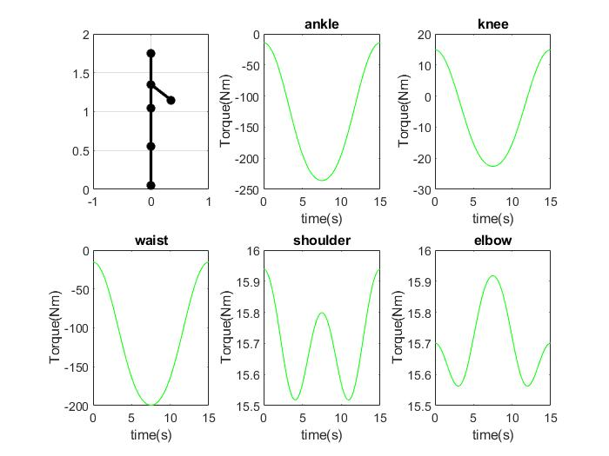

Figure:13: Torque graph for sitting down and getting up without load at operation time =15 s

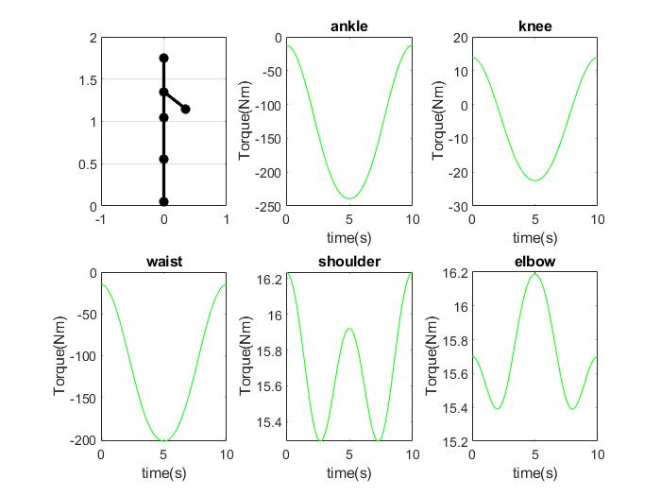

Figure:14: Torque graph for sitting down and getting up without load at operation time =10 s

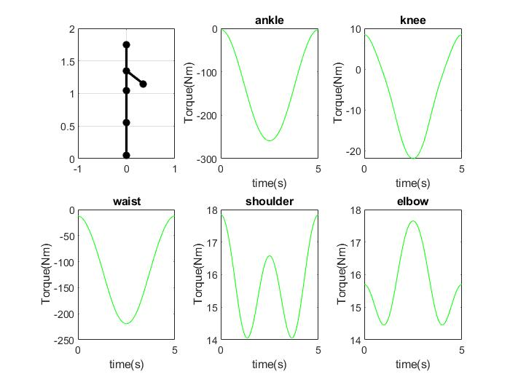

Figure:15: Torque graph for sitting down and getting up without load at operation time = 5 s

1. Maximum torque on human joints at different time of operation

|  |  |  |  |  |  |  |
| --- | --- | --- | --- | --- | --- | --- |
| S.no | Operation time (in sec) | Maximum Torque on ankle (in Nm) | Maximum Torque on knee (in Nm) | Maximum Torque on waist (in Nm) | Maximum Torque on shoulder (in Nm) | Maximum Torque on  Elbow (in Nm) |
| 1. | 15 | 235.8 | 22.61 | 199.2 | 15.94 | 15.92 |
| 2. | 13 | 236.8 | 22.58 | 200.2 | 16.02 | 15.99 |
| 3. | 12 | 237.5 | 22.56 | 200.7 | 16.07 | 16.04 |
| 4. | 10 | 239.4 | 22.50 | 202.4 | 16.24 | 16.17 |
| 5. | 9 | 241 | 22.45 | 203.7 | 16.36 | 16.3 |
| 6. | 8 | 243.1 | 22.39 | 205.6 | 16.54 | 16.46 |
| 7. | 7 | 246.1 | 22.29 | 208.2 | 16.79 | 16.7 |
| 8. | 6 | 250.9 | 22.14 | 212.2 | 17.19 | 17.05 |
| 9 | 5 | 258.9 | 21.89 | 219.1 | 17.84 | 17.65 |
| 10 | 4 | 273.4 | 21.43 | 231.2 | 19.50 | 18.75 |

**Case 6: Weight of Human = 85 kg, Payload= 25kg 🡪**

1. Payload on hands= 25kg

Action: sitting and getting up

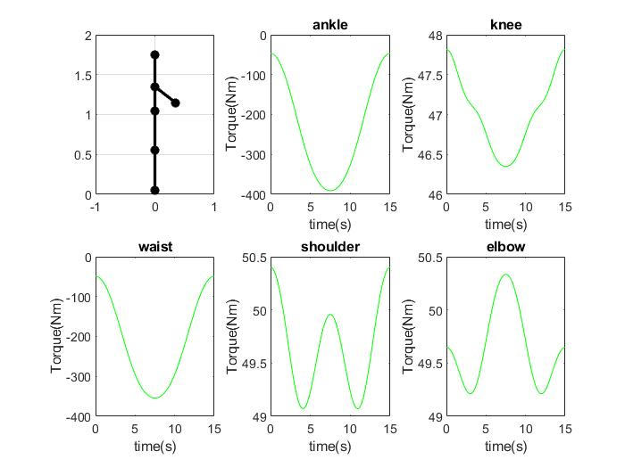 Figure:16: Torque graph for sitting down and getting up without load at operation time = 15 s

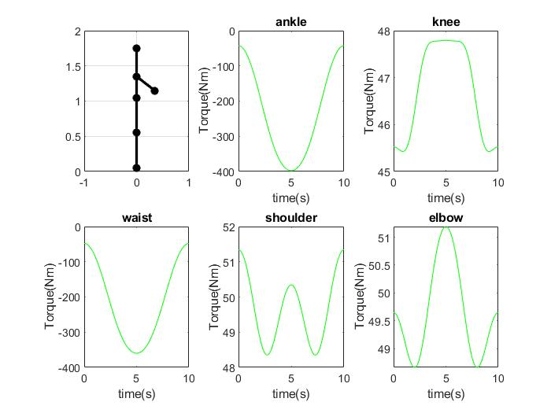

Figure:17: Torque graph for sitting down and getting up without load at operation time = 10 s

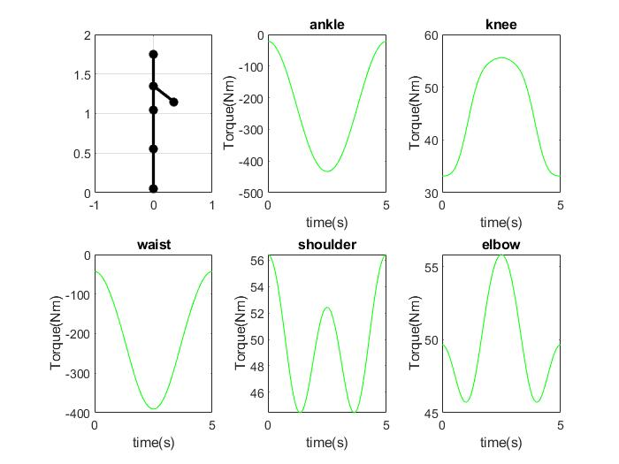

Figure:18: Torque graph for sitting down and getting up without load at operation time = 5 s

1. Maximum torque on human joints at different time of operation

|  |  |  |  |  |  |  |
| --- | --- | --- | --- | --- | --- | --- |
| S.no | Operation time (in sec) | Maximum Torque on ankle (in Nm) | Maximum Torque on knee (in Nm) | Maximum Torque on waist (in Nm) | Maximum Torque on shoulder (in Nm) | Maximum Torque on  Elbow (in Nm) |
| 1. | 15 | 391 | 47.82 | 354.2 | 15 | 50.33 |
| 2. | 13 | 392.8 | 47.21 | 355.7 | 50.65 | 50.56 |
| 3. | 12 | 394 | 47.2 | 356.7 | 50.82 | 50.72 |
| 4. | 10 | 397.6 | 47.79 | 359.9 | 51.34 | 51.19 |
| 5. | 9 | 400.3 | 48.4 | 362.3 | 51.74 | 51.55 |
| 6. | 8 | 404.3 | 49.26 | 365.5 | 52.29 | 52.06 |
| 7. | 7 | 410 | 50.5 | 370.5 | 53.1 | 52.8 |
| 8. | 6 | 418.7 | 52.42 | 378 | 54.35 | 53.93 |
| 9 | 5 | 433.2 | 55.6 | 390.5 | 56.42 | 55.82 |
| 10 | 4 | 459.9 | 61.45 | 413.5 | 60.23 | 59.29 |